Dharmendrasinhji Arts College, Rajkot
Dr. Yagnik Road, Ph./Fax No. (0281) – 2465632
Govt. Of Gujarat
(Affiliated with Saurashtra University)

7.1.2 - The Institution has facilities for alternate sources of energy and energy conservation measures

Solar Panel
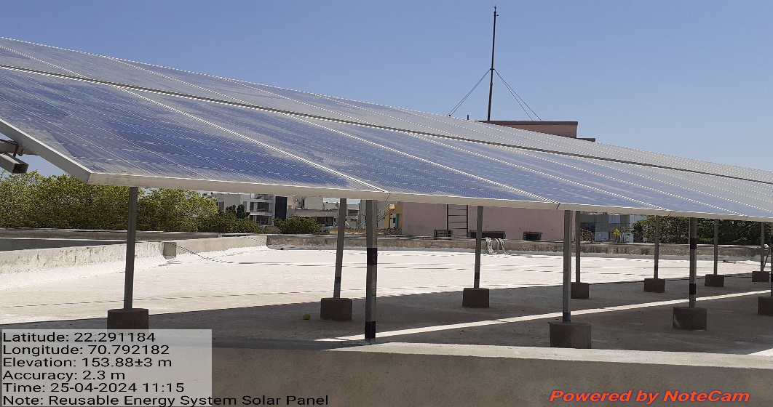
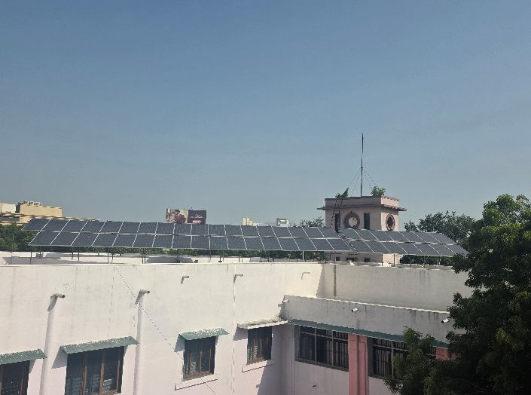

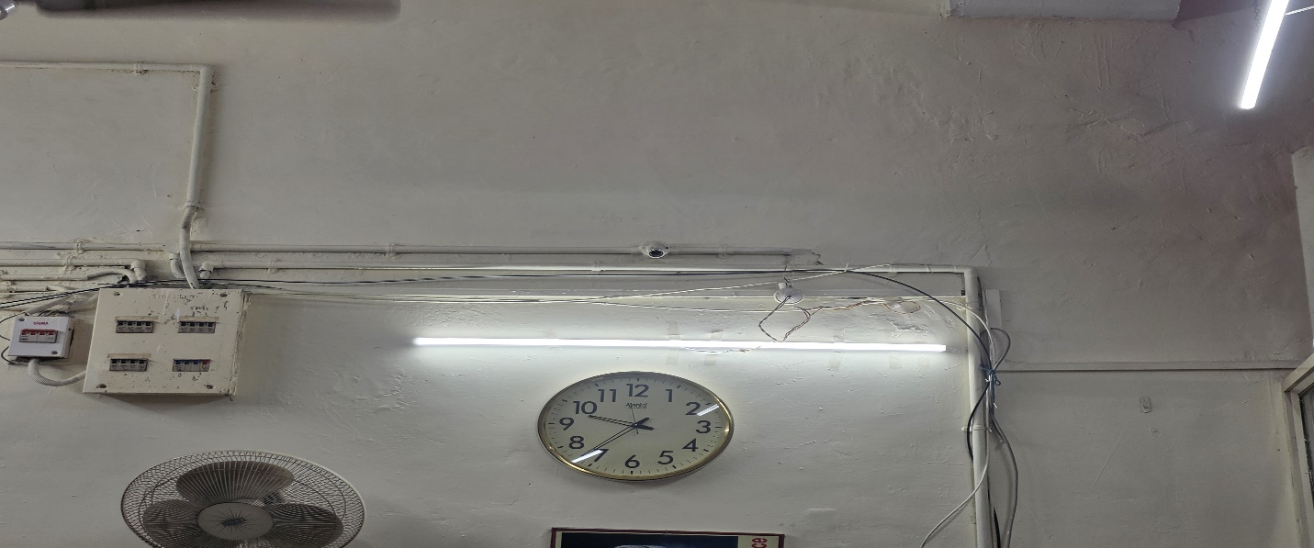
Use of LED bulbs

